# JAISHREE S 231901011

**EX.NO:11C DATE:06.10.2024**

# REMOTE PROCEDURE CALL FOR SORTING ARRAY OF ELEMENTS - XML RPC

**AIM:**

To implement remote procedure call for Sorting Array of Elements

# PROGRAM:

**server.py**

from xmlrpc.server import SimpleXMLRPCServer def sort_array(array):

return sorted(array)

server = SimpleXMLRPCServer(("localhost", 8000)) print("XML-RPC server running on port 8000...") server.register_function(sort_array, "sort_array") server.serve_forever()

# client.py

import xmlrpc.client

proxy = xmlrpc.client.ServerProxy("http://localhost:8000/") user_input = input("Enter a list of integers separated by spaces: ") array = []

for item in user_input.split(): array.append(int(item))

sorted_array = proxy.sort_array(array) print("Sorted array:", sorted_array)

# OUTPUT:

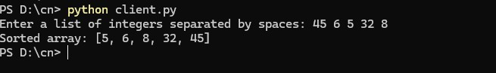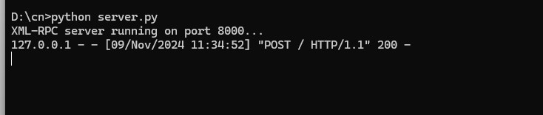

**RESULT:**

Hence, REMOTE PROCEDURE CALL FOR SORTING ARRAY OF ELEMENTS XML

RPC has been executed

# CSE CYBER SECURITY